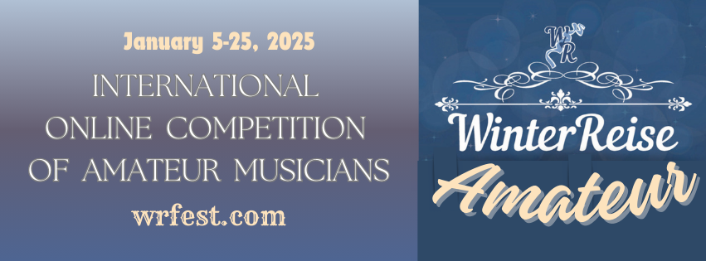

International Online Competition for Amateur Musicians
Winterreise - Amateur
Participants:
Amateur musicians of all academic disciplines who are older than 15 years of age are invited to participate. No upper age limit.

Objectives of the Competition
Amateur musicians are individuals from various professions who engage in classical music performance as a serious hobby, a form of self-expression that is not their professional activity or source of income. These musicians — engineers, doctors, chemists, architects, lawyers, and more — are "amateurs" in the etymological sense of the word, as they share a true love for music and devote their free time to it while adhering to the same high standards as professional musicians.

2. Organizers of the Competition
The International Chamber Music Festival "Winterreise" www.wrfest.com

3. Organizing Committee
- Natalia Korshunova, President of the Competition
- Sergey Brodsky

4. Jury
- Anna Arzamanova (piano, Gnessin Moscow Special School of Music, Russia)
- Natalia Korshunova (piano, Russia)
- Svetlana Abzalova-Kovaleva (vocals, Associate Professor of Moscow State Conservatory, Russia)
- Sergey Brodsky (strings, Russia/Israel)
- Andrey Sannikov (wind instruments, Russia)

5. Creative Partners
- The International Cultural Project "Italian Seasons"
- The International Chamber Music Festival "Winterreise - Winter Journey" (Moscow/Russia) www.wrfest.com
- AD GROUP ART advertising and information agency

6. Categories
- Solo (all disciplines)
- Ensembles (instrumental or vocal, from 2 to 7 participants)

7. Competition Categories
The competition is held in two categories:
a) Amateur musicians without formal musical education
b) Amateur musicians who have completed secondary or higher musical education but have not worked professionally in music for more than three years

8. Competition Dates and Venue
- Dates: January 5-25, 2025
- Venue: ONLINE

9. Competition Program
Participants must submit video recordings.
The performance must consist of one or more pieces of the classical genre chosen by the contestant. It is allowed to perform one or more movements from a large cyclic work. Transcriptions and arrangements are allowed.
- Maximum duration of the recording: 15 minutes.

10. Competition Procedure
The competition consists of one round.
Participants determine the order of their performance pieces.
In the solo category, pieces must be performed from memory. In the ensemble category, participants may use sheet music.
To participate, each soloist or ensemble should fill out the attached application form. The following documents must be submitted with the application:
- A photo of the soloist or ensemble (minimum 3 MB);
- A brief creative biography of the soloist or ensemble in free form;
- A copy of the passport or birth certificate of the soloist or each ensemble member;
- A copy of the receipt for the entry fee payment;
- A link to the video recording of the performance.
Ensemble participants submit one application for the group.
The completed application form, accompanying documents, and the video link must be emailed by December 25, 2024 to: competition.winterreise@gmail.com. The subject line should read: Winterreise_Amateur_2025.
Video recordings should be uploaded to YouTube or any platform with open access, and the link must allow direct viewing without downloading.
- No additional sound or video editing is allowed.
- The performer’s hands, instrument, and face must be visible at all times.
- The performance may be recorded in separate video files.
Any changes to the competition program must be reported by January 5, 2025, and approved by the Organizing Committee.
The jury reserves the right to award or withhold prizes, divide awards, and establish additional special prizes and a Grand Prix.

11. Financial Conditions and Entry Fee
The entry fee for participants is 30 EUR netto per soloist or ensemble member.
The entry fee is non-refundable.

12. Special Conditions
Participants will not receive any fees for performing at the competition or for the use of recordings and broadcasts of these performances.
The Organizing Committee reserves the exclusive rights to distribute audio and video recordings and broadcast the competition performances.
By signing the application form, participants agree to all the conditions outlined above.

13. Prizes and Awards
All participants shall receive feedback from the jury members and certificates as competition participants, diploma recipients, or laureates in each category. Prizes include:
- Special Prize from the Winterreise International Chamber Music Festival: a diploma and an invitation to perform at festival concerts in Moscow in 2025-2026 (without covering travel and accommodation expenses).
- Free online masterclasses with jury members.

14. Payment Details for Competition Fees
Please, use Paypal
https://www.paypal.me/wrfest
Payment comment: Quota associativa

15. Contact Information
www.wrfest.com
FB page: www.facebook.com/wrfest
VK page: https://vk.com/club217210057
Email: competition.winterreise@gmail.com

Application Form
For Participation in the International Online Competition for Amateur Musicians "Winterreise - Amateur"

Full Name of Participant
(or Ensemble Members)

Date of Birth of Participant
(or Ensemble Members)

Country, City
Nomination

Category

Contact Information of Participant
(or Ensemble Representative):
Phone, Email

Full Name of Educational Institution
(if applicable)
Full Name of Teacher
(if applicable)

Full Name of Accompanist
(if applicable)

Competition Program  (please indicate the duration) | Piece |  | Duration

